CPE 151

Digital IC Design

Project No.1

Daniel Komac

[komacdan@hotmail.com](mailto:komacdan@hotmail.com)

3/13/2020

**Contents**

**S. No Section Page No.**

**1.** Inverter Schematic 5

**2.** Inverter Testbench 6

**3.** Inverter Testbench Waveform 7

**4.** Inverter Layout 8

**5.** Inverter DRC 9

**6.** Inverter LVS 10

**7.** Inverter Post-layout 12

**Inverter**

**(W/L)_n = 1.8/.18**

**(W/L)_p=3.6/0.18**

**Schematic(Inverter):**

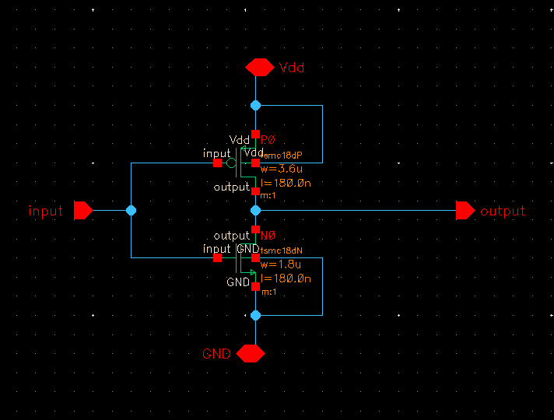

**Test Bench(Inverter):**

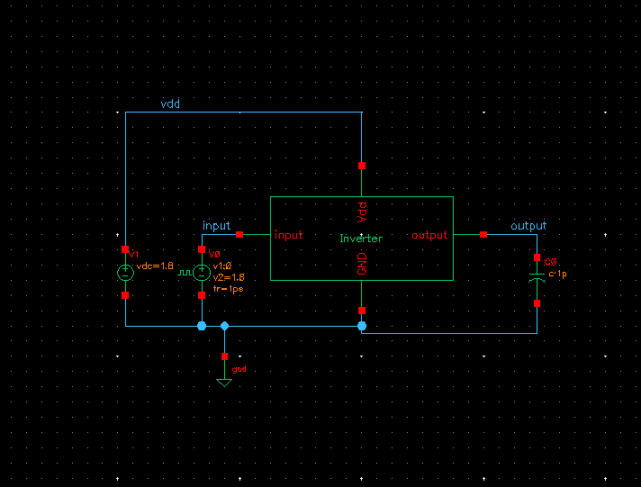

**Test Bench Waveform(Inverter):**

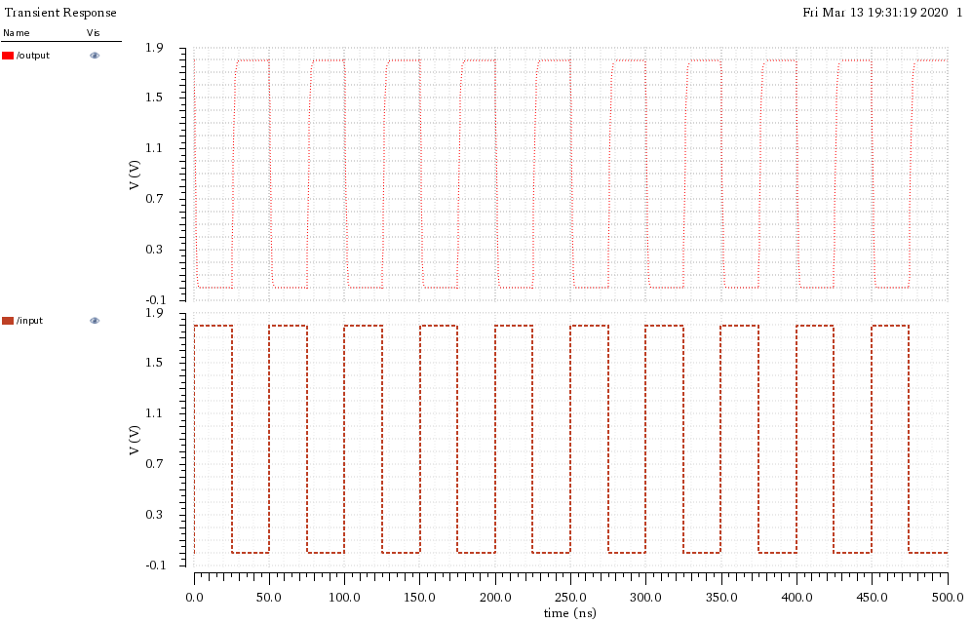

**Layout (Inverter):**

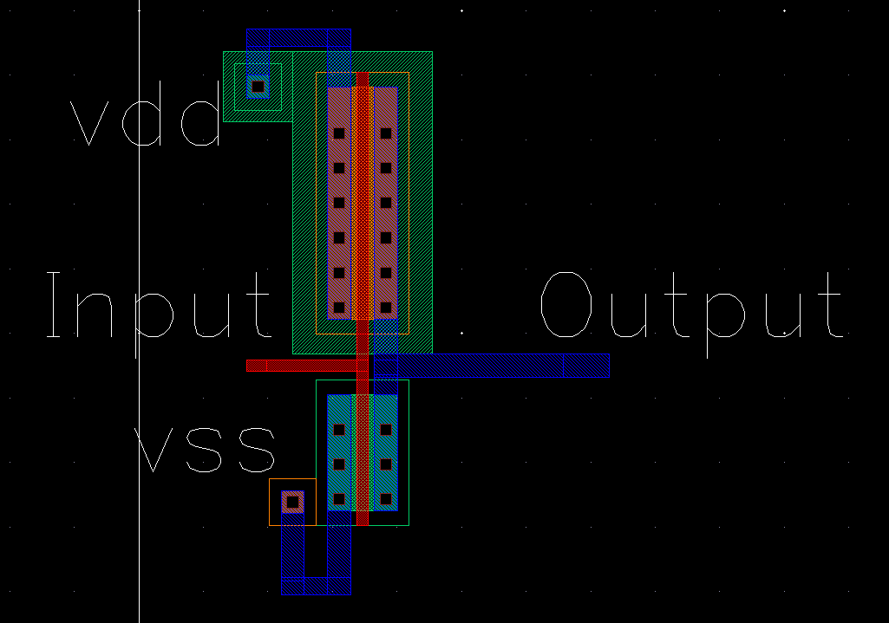

**LVS(Inverter):**

@(#)$CDS: LVS version 6.1.7-64b 09/27/2016 19:41 (sjfhw305) $

Command line: /software/cadence/installs/IC617/tools.lnx86/dfII/bin/64bit/LVS -dir /gaia/class/student/komacd/CadDemo/LVS -l -s -t /gaia/class/student/komacd/CadDemo/LVS/layout /gaia/class/student/komacd/CadDemo/LVS/schematic

Like matching is enabled.

Net swapping is enabled.

Using terminal names as correspondence points.

Compiling Diva LVS rules...

Net-list summary for /gaia/class/student/komacd/CadDemo/LVS/layout/netlist

count

4 nets

4 terminals

1 pmos

1 nmos

Net-list summary for /gaia/class/student/komacd/CadDemo/LVS/schematic/netlist

count

4 nets

4 terminals

1 pmos

1 nmos

Devices in the rules but not in the netlist:

cap nfet pfet nmos4 pmos4

The net-lists failed to match.

layout schematic

instances

un-matched 0 0

rewired 0 0

size errors 0 0

pruned 0 0

active 2 2

total 2 2

nets

un-matched 0 0

merged 0 0

pruned 0 0

active 4 4

total 4 4

terminals

un-matched 4 4

matched but

different type 0 0

total 4 4

Probe files from /gaia/class/student/komacd/CadDemo/LVS/schematic

devbad.out:

netbad.out:

mergenet.out:

termbad.out:

T -1 GND /GND

? Terminal GND in the schematic is not present in the layout.

T -1 Vdd /Vdd

? Terminal Vdd in the schematic is not present in the layout.

T -1 input /input

? Terminal input in the schematic is not present in the layout.

T -1 output /output

? Terminal output in the schematic is not present in the layout.

prunenet.out:

prunedev.out:

audit.out:

Probe files from /gaia/class/student/komacd/CadDemo/LVS/layout

devbad.out:

netbad.out:

mergenet.out:

termbad.out:

T -1 Input /Input

? Terminal Input in the layout is not present in the schematic.

T -1 Output /Output

? Terminal Output in the layout is not present in the schematic.

T -1 vdd /vdd

? Terminal vdd in the layout is not present in the schematic.

T -1 vss /vss

? Terminal vss in the layout is not present in the schematic.

prunenet.out:

prunedev.out:

audit.out:

**Post Layout-Simulation(Inverter):**

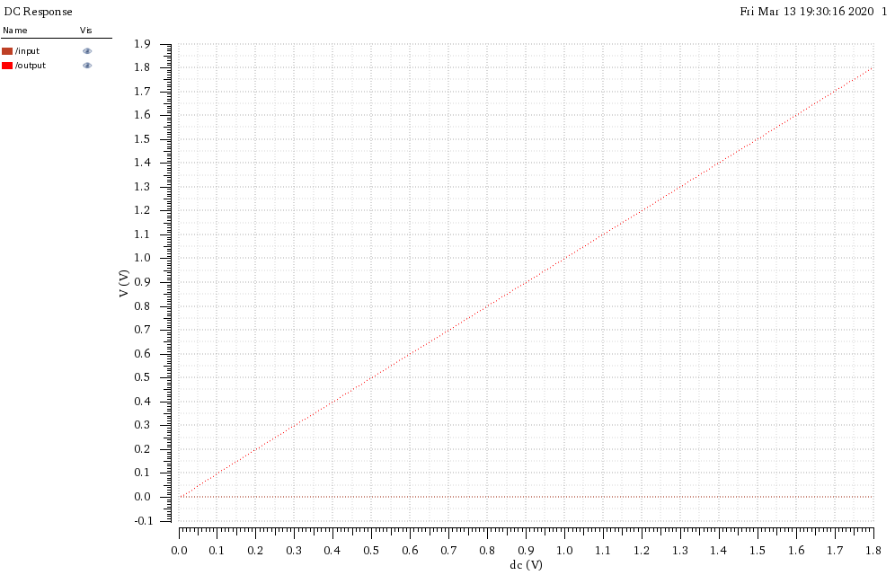

**Conclusion:**

|  |  |  |  |  |
| --- | --- | --- | --- | --- |
| **S. No.** | **Description** | **Rise Time(us)** | **Fall Time(us)** | **Delay Time(us)** |
| 1. | Inverter | 0us | 0.001us | 0us |